GTI-R Speedo Conversion and De-limiting. Author - Martin Bell www.GTI-R.co.uk

Preparation
Unless you have done this conversion before - I would STRONGLY advise you to read all though these instructions, BEFORE you touch anything.
These instructions apply to all GTI-R’s with any normal factory fitted original equipment extras. The converter described is designed to change the standard 180 kph speedo face to read in mph and remove the 112 mph built in speed restriction at the same time.
There may be small variations to the following procedure required on certain cars. (Mine included!). However, I have done this job personally many times on many different GTI-R’s, (And every one has worked perfectly!). If you use a little common sense, take your time and think about what you are doing, it is certainly not difficult.
Please Note:
If you have any aftermarket fitted accessories which use the signal from the speed OUTPUT signal wire from the speedo head, then things can get a little more complicated, although to be honest, the only problems I have come across to date, have been with the Apexi Rev / Speed Meter *** and the various SLD's *** (speed limit defencers).
These above units *** will not work properly with the Speedo Converter/Delimiter described in these instructions.
SLD's convert the output signal FROM the speedo head, and this delimits the car - but of course the speedo would still read in KPH and the odometer would still clock up in Km. Many imported GTI-R's have simply been fitted with a 120 mpg speedo face and have NOT been deristricted. Others have been fitted with a 120 mph face and an SLD to delimit the car. - If an SLD is fitted it can be removed and the wire it interrupts joined back together.
On the Rev/Speed Meter one of it's connections taps onto the speedo OUTPUT signal to the ECU - and because the delimiter / converter described here divides the INPUT signal by 1.6093 the road speed on the Rev/Speed meter will always read slow.
Also - if you have an alarm system that locks the doors automatically at a set road speed, you may find you have to go a lot faster before is works.
If you have any queries about any on the above or the following instructions, please Email me on Martin@GTI-R.co.uk , and I do my best to help. Similarly, if there is anything I have got wrong or that could be explained in a better way, please let me know.
I can accept NO RESPONSIBILITY for any installation that you undertake, these instructions are intended as a helpful guide for those GTI-R owners who feel able, and confident enough to tackle the conversion themselves. It is not difficult, but if you have any doubts, get a specialist to do the work for you.
You will need:
1) Short Phillips head screwdriver.
2) Long Phillips head screwdriver.
3) Small electrical type Phillips head screwdriver.
4) Approx 2 metres of string or thin flexible wire.
5) A sharp knife, or wire-stripping tool.
6) Small soldering iron and solder or high quality cable crimp type connectors.
7) Electrical Insulating Tape.
8) GTI-R 6 wire delimiter / converter and speedo kph to mph sticker. These are the only units I now use and recommend. These are the same units used by several of the specialist converters who charge £150.00 plus for this job. (It’s actually a fair enough price, when you consider you are also buying the labour and the knowledge to do the job as well as the unit itself.) If you do the job yourself, I can supply the speedo converter/delimiter I use for £80.00. - AND I’ll give you any extra help or advice you may need by Email.
9) You will also need 30 minutes or maybe an hour or more if this is the first time you have ever removed a GTI-R dashboard.
As a precaution it is always a good idea to disconnect your battery, before you start any work, which in any way interferes with anything electrical on any vehicle.
Be aware however, of any affect this may have on your alarm system – you may for instance, have to put it into valet mode before disconnecting the battery.

OK - STEP BY STEP INSTRUCTIONS FOLLOW:

1) Remove Heater Flap Cable and Secure.
The most difficult part of this job can be re-fitting the cable heater flap cable that runs from the right side centre vent lever, down through the back of the dash to the heater flap control.
THEREFORE - to make re-assembly simple, and BEFORE you start ripping the dash out - unclip the outer cable - which is just to the top left of the cable as shown on the top picture - (the clip should stay in position on its mounting bracket) - pull the eyelet off the heater flap and thread a length of wire or string through the eyelet. This will allow you to guide the control cable back down to its correct position during re-assembly. This operation is a little easier if you first remove the driver’s side kick plate to the left of the clutch pedal. (Just 2 screws hold this in place.) Don’t be surprised to see a multitude of wires behind here - and - if you didn’t know where your ECU lives – well you do now!
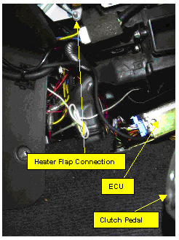
2) Remove Centre Consul and Dash Panel
First of all, lift up the rear edge of the gear lever surround (secured by 2 clips) and then pull backwards to remove. At this point you can lift the surround up over the gear lever, which keeps it out of the way.
Now remove the 2 screws at the bottom of the centre consul - they are easier to get at, (with a long Phillips screwdriver), if you take the ashtray out first. (On my car the AFC and ITC are mounted where the ashtray/cig. lighter was). By now gently pulling the lower edge of the centre consul back, the top edge will come out of its locations on the underside of the dashboard. You can now unclip the harness connectors to the Cig Lighter, the Hazard W/L Switch and the Rear Screen Heater Switch. Don’t just try to yank these connectors off - they all have locating clips, which have to be depressed for removal.
Unless you have a load of extra stuff connected up through the consul (as I do!), you can now take the consul surround off and put in on the back seat out of the way. I just pull mine forward a little to give just enough clearance for the next step.
Incidentally, you now have access to the Radio, Heater Controls, Drinks Holder, all of which are held in place by the same size screws. You don’t need to remove any of them for this job though.
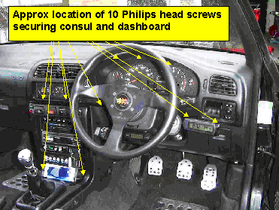
3) Remove Outer Dash Panel Surround.
Loosen the steering column height adjustment lever and lower the column as far as it will go. (You may already have it in this position of course!)
There are 5 screws on the underside of the Dash Panel, which are now easily accessible. Again, their approximate positions are marked on the 2nd photo down. If you take out more than 5 screws, then you are getting a little too enthusiastic and doing unnecessary work! If you contort yourself in the cockpit and look at what you are doing, it’s fairly obvious which 5 screws have to be removed.
Now remove the 3 remaining screws which are recessed into the underside of the dash surround over the speedo / tacho. This is where you will probably need a short Phillips headed screwdriver.
OK – you are now ready to remove the dash surround. You should find at this stage that the lower edge of the dash panel moves freely out and in by about half an inch or so. If not then either you have not removed all 5 lower screws or you have removed the wrong ones!
The top of the dash panel is now held in place by 4 spring clips. (I could be wrong here; it may be 3 or 5 clips). In fact, if the dash has ever been removed before, you may find there are less clips than normal, because they tend not to be put back and/or get broken if not carefully removed. However, these clips can be a tight fit - and you may even think that there must be other screws holding the panel in place, but as long as you have followed the above instructions, there are NO MORE screws to remove. By wiggling the top of the dash panel up and down and pulling gently at the same time, the whole panel should now release without too much trouble.
Once the dash is released, you can now disconnect the door mirror controls harness plug from the back of the dash - right hand side.
It is now possible to completely remove the dashboard surround. The heater vents simply come away with the dash surround and there is nothing more to disconnect. It CAN BE A BIT AWKWARD manoeuvring the panel past the steering wheel and steering wheel surround, but I have never yet had to remove either to get the dash panel surround out. Don’t move the Dash surround too far away from the facia or you will pull that carefully connected string out of the dashboard and you may then have a hell of a job feeding the heater vent cable back down inside the dashboard when you come to put it all back together!
At this point you now have access to the separate Oil Temp / Pressure Gauges and Factory Boost Gauge. But again, there is no need to remove them for this job.
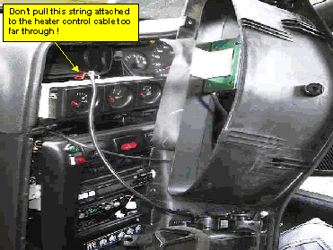
4) Remove Speedo Cluster Panel
Dead easy – just 4 screws – 2 top, 2 bottom to take out, then pull the speedo head assembly back towards you and gently remove the 3 harness connectors on the rear of the speedo / tacho head. DON’T try and force these connectors to come out, they are all secured by proper locating clips. These clips need to be pushed in to release the connector. Note where each connector goes – you can’t fit them back wrongly, but it’s far easier if you remember where each one goes.
You can now take the speedo cluster out and carefully release the clear plastic front window buy easing it out of its clips. The MPH sticker can now be stuck over the KPH on the speed dial face. Replace the clear plastic cover.
Incidentally, if you now look down through the panel where the speedo was fitted, you can now see the clutch pedal bracket. It is worth checking the bracket for movement at this stage as they have been known to fracture and thus cause complete loss of clutch action. You can actually reach down through the panel and feel around the pedal bracket, whilst operating the clutch. A very small amount of bracket flex is normal, but if movement is excessive, then you have another job on your hands!
4) Wiring in the Converter / Delimiter.
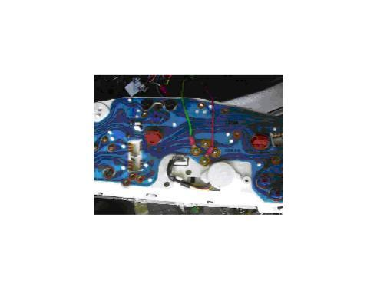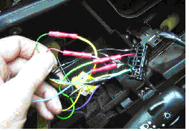
In above left picture - the green wire is now black and connects to the TOP speedo mounting screw. (Not the left as shown).
On the converter unit, the RED wire connects to the BOTTOM speedometer mounting screw and the BLACK wire connects to the TOP speedometer mounting screw. Don’t take any notice of the wire colours on the above right picture these have been changed since the pictures were taken. ALSO, don't take any notice of the position of the wires in the picture above right - they are NOT always in the same place.
Locate the central black instrument panel plug and cut the RED wire about 3 cm from the plug. Connect the BROWN converter wire to the LOOM side of this RED wire and the converter BLACK wire to the PLUG side.
You now need to locate the GREEN wire that runs into the central (speedo) plug. This is the wire from the transmission speed sensor which carries the signal that will be interrupted and converted by the converter unit. You need to cut this GREEN signal wire about 3 cm from the plug and connect the GREY converter wire to the LOOM side of this GREEN wire and the WHITE converter wire to the PLUG (speedo) side of the wire. Solder the connections if possible and cover with heat shrink tubing or insulation tape. If soldering is not your scene, then use good quality crimp connectors or male/female type connectors. Secure the converter unit to the cable harness in a convenient position.
Before you put everything back together, just get enough back in place so that you can safely drive down the road to make sure the speedo in working OK. I have never had a problem with these units, but I did connect one up wrongly once and, having completely re-assembled the dash etc, I then had to take it all apart again!
Best of luck.
Martin Bell
Email Martin@GTI-R.co.uk
Web www.GTI-R.co.uk

